**Application Summary**

1. Login Screen with name and formatted email. If not fill name or email, will show required error and wrong email format will show wrong format error.

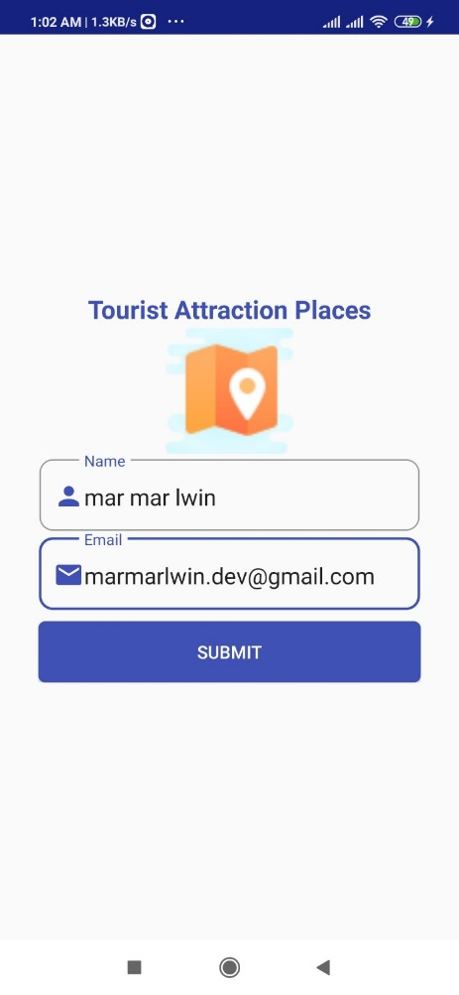

1. Show attractions 5 places with photo. Can select multi item places on either markers or list items.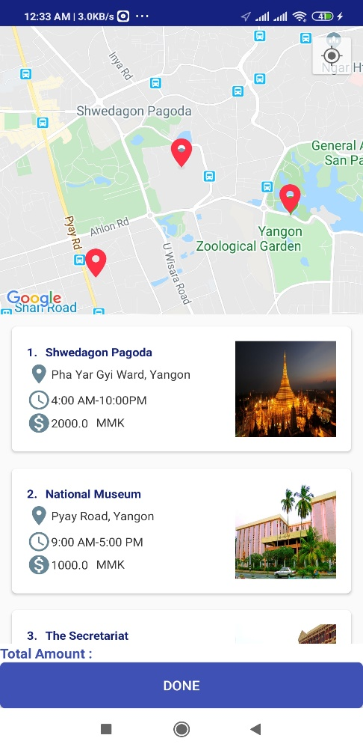 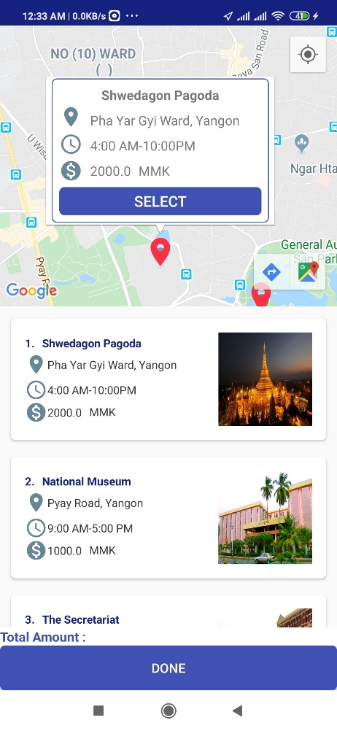

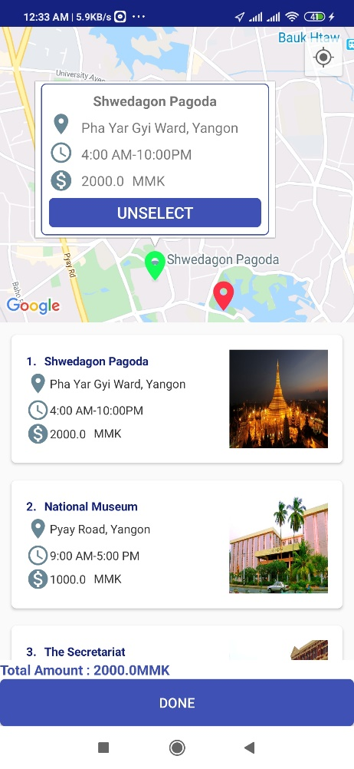 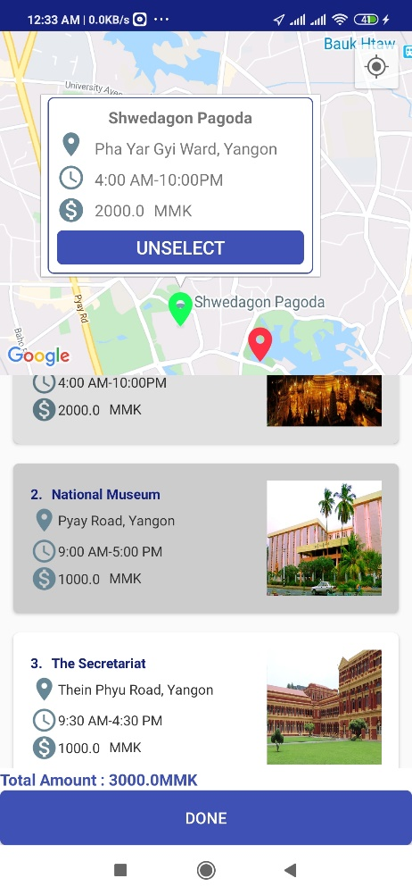

1. After selecting item, can click “Done” button. Alert Dialog will show total amount confirmation.When you press back button without clicking “Done” button. Exit confirmation alert will show.

